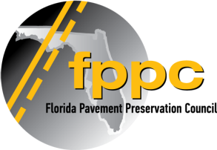
Code of Ethics
As a member of the Florida Pavement Preservation Council (FPPC), our Company and employees will promote pavement preservation honestly and ethically wherever we operate in Florida. We will constantly seek improvement in the quality of pavement preservation services, products and operations and will create a reputation for honesty, fairness, respect, responsibility, integrity, trust and sound business judgment. No illegal or unethical conduct on the part of any member or member company will be allowed which compromises FPPC principles. The ethical performance of the FPPC is the sum of the ethics of the men and women who are members. Thus, we are all expected to adhere to high standards of personal integrity.
Members must never permit their personal interests to conflict, or appear to conflict, with the interests of the FPPC or any governmental agency. Members shall avoid using the name of the Florida Pavement Preservation Council to advance their private business or personal interests at the expense of the FPPC or government agencies.
No bribes, kickbacks or other similar remuneration or consideration shall be given by any member or member organization in order to attract or influence business activity. Members shall avoid giving gifts, gratuities, fees, bonuses or excessive entertainment, in order to attract or influence business activity.
FPPC members will refrain from gathering competitor intelligence by inappropriate means and refrain from acting on knowledge which has been gathered in such a manner. The FPPC members will avoid exaggerating or disparaging comparisons of the services and competence of their competitors.
FPPC members agree to disclose unethical, dishonest, fraudulent and illegal behavior.
Violation of this Code of Ethics can result in removal from FPPC membership.
Remember that good ethics is good business!

I, _________________________________, ________________________________
(Print Name) (Title)
Do hereby acknowledge that I have read the foregoing Code of Ethics of the Florida Pavement Preservation Council, and do agree that our Company and employees will comply with the statements contained therein.

______________________________________, _____________________________________
(Signature of FPPC Member) Date

