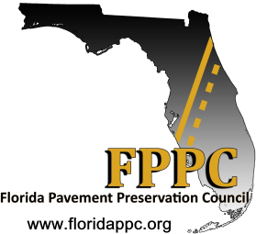
Workshop & Webinar
December 17, 2019
Tampa, Florida

Purpose: The Pavement Preservation Overview will provide the audience with a clear understanding of the importance of managing their pavements as long-term investments. It provides information on basic pavement preservation concepts and the different treatments available. New tools will be introduced for agency staff and elected officials struggling with current budget constraints to successfully address the needs of their road/street network. The benefits of preservation treatments will be briefly discussed to demonstrate that when pro-actively applied to sound pavements, improved pavement performance, longer pavement life and increased customer satisfaction result.

Workshop: This event is intended to provide valuable information for pavement practitioners to better manage their road/street network. Professional License CEUs will be provided to participants completing the workshop through Michigan State University. Cost: The complete workshop with lunch included is $25.
Webinar: A first 60 minutes of the workshop (9:30 to 10:30) will be broadcast as a webinar to interested parties unable to attend the entire workshop. Cost: Free to all participants.

Audience: The workshop is intended for elected officials, local agency managers, engineers, supervisors, crew leaders, and engineering consultants.

Sponsor: This workshop is presented by the Florida Pavement Preservation Council (FPPC).

Presenters:
Chris Evers, Executive Coordinator, Florida Pavement Preservation Council
Larry Galehouse, Founder & Director Emeritus, National Center for Pavement Preservation
Ken Grzybowski, CEO, PRI Asphalt Technologies, Inc.

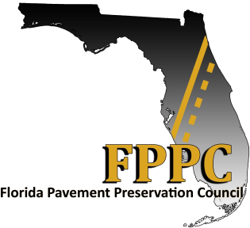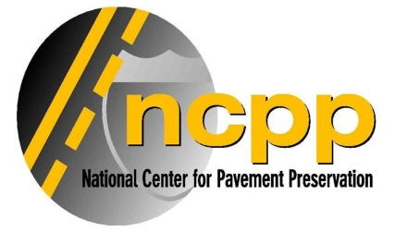
Workshop Agenda

9:30 a.m. Introductions

9:45 a.m. The Florida Pavement Preservation Council Overview

10:00 a.m. The Pavement Preservation Concept
    - Making the Case for Pavement Preservation
    - Applied Asset Management Principles
    - Terminology
    - Understanding Remaining Service Life

10:30 a.m. Break

10:45 a.m. Addressing Pavement Distresses with Preservation Treatments

11:45 a.m. Lunch

12:30 p.m. The Toolbox - Pavement Preservation Treatments

1:30 p.m. Asphalt Emulsion Basics

2:30 p.m. Break

2:45 p.m. The Pavement Network Evaluation Tool

3:30 p.m. Adjourn

