Missouri Pavement Preservation Council

Origins

Missouri Contact:

or

Larry Galehouse

National Center for Pavement Preservation

galehou3@egr.msu.edu
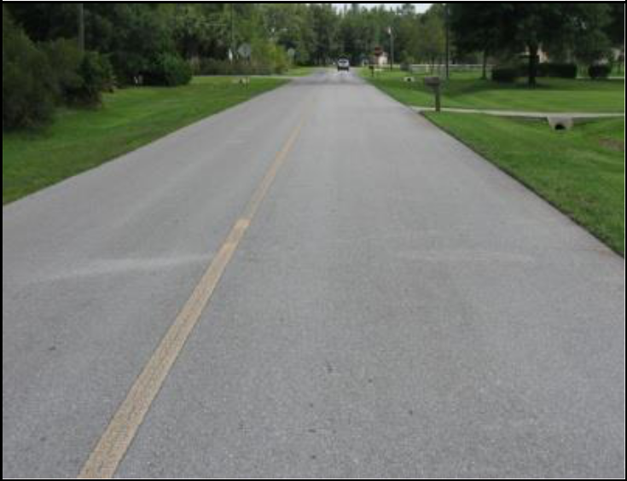
Missouri Pavement Preservation

Mission:

Further Pavement Preservation Education in Missouri through the National Center for Pavement Preservation

Missouri Pavement Preservation Council

Background

Several members of the pavement preservation industry recognized the need to offer a neutral and productive environment for pavement preservation and asset management education in Missouri.

Training Courses

Training courses are offered various times throughout the year. Courses are taught by national experts to provide you with the latest best practices on topics that include:

Top-of the-Curve

Basis Concepts for Pavement Preservation Micro-Slurry
Chip Seal

Applied Asset Management

These workshops provide information on basic pavement preservation concepts and implementation. The information will be introduced to agency staff and elected officials who may be struggling with current budget constraints. The information is designed to address the needs of their highway/street network. The benefits of preservation treatments will be reviewed and information shared. When the treatments are pro-actively applied to sound pavements there will be improved pavement performance, longer pavement life and increased customer satisfaction. Courses qualify for Continuing Education Units (CEUs).

Please see the website, contact the MOPPC coordinator, or contact NCPP for the schedule of courses.

Missouri Pavement Preservation Council

Strategic Goals

Promote the implementation and benefits of pavement preservation principles through training and education throughout communities in Missouri.

Provide recommended regional specifications and guidelines for pavement preservation techniques in Missouri.

Foster beneficial technology transfers between academia, industry, and agencies.

Become a Member of the MOPPC

Membership in the MOPPC is as simple as making a tax deductible donation to NCPP c/o Michigan State University [a non-profit public university under the Internal Revenue Code 501(c)3]. Make checks payable to: NCPP c/o Michigan State University, 2857 Jolly Road, Okemos, Michigan 48864. Please contact Larry Galehouse or NCPP for further details. Membership in the categories below list donation requirements and benefits for 2021:

 | Category |  | Donation |  | Benefits
 | Industry + |  |  |  | Discounted rate access to all
 |  |  | $2,000 Annually |  | MOPPC activities during
 | Member
 |  |  |  |  | membership period.
 | Associate |  |  |  | Member rate access to MOPPC
 |  |  | $1,000 Annually |  | activities during membership
 | Member
 |  |  |  |  | period.
 | Academic |  |  |  | Member rate access to MOPPC
 |  |  | $500 Annually |  | activities during membership
 | Member
 |  |  |  |  | period.
 | Government |  |  |  | Member rate access to MOPPC
 |  |  | Free |  | activities during membership
 | Member
 |  |  |  |  | period.

