Florida Pavement Preservation Council

The Florida Pavement Preservation Council (FPPC), organized in 2010, is comprised of contractors, suppliers, consultants, local government officials, and academia. The purpose of FPPC is to support education and advance outreach assistance to local agencies throughout Florida for pavement preservation and asset management. The National Center for Pavement Preservation (NCPP) has partnered with the FPPC to champion our effort in Florida. The NCPP is a non-profit, quasi-government organization recognized nationally as the leader in pavement preservation. The NCPP administers the AASHTO TSP•2 (Transportation System Preservation Technical Services Program) and is actively engaged with the FHWA Office of Asset Management. The Florida Board of Professional Engineers recently certified NCPP as an authorized provider of continuing education credits in Florida.

Florida Contact:

Chris Evers
(727) 638-1699
chris@floridapavementpreservationcouncil.com

or

Larry Galehouse

National Center for Pavement Preservation

galehou3@egr.msu.edu
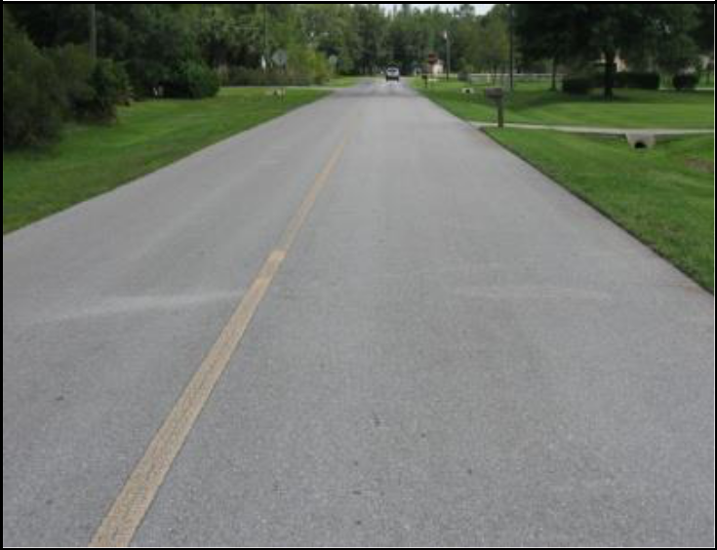
Florida Pavement Preservation

Mission:

Further Pavement Preservation Education in Florida through the National Center for Pavement Preservation

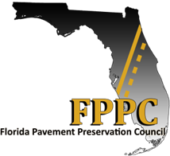

Florida Pavement Preservation Council

Background

Several members of the pavement preservation industry recognized the need to offer a neutral and productive environment for pavement preservation and asset management education in Florida. They approached the National Center for Pavement Preservation (NCPP) about organizing an educational outreach initiative for local agencies in Florida. This new Florida outreach is the first dedicated initiative within the United States to focus pavement preservation educational efforts at the local government agencies. The Florida Pavement Preservation Council (FPPC) was formed to provide financial resources to advance this effort within the State of Florida. The NCPP contact in Florida is Chuck Williams, who is the coordinator for the FPPC. Mr. Williams has provided invaluable assistance to organize the education effort. The experience that Mr. Williams possesses will help focus training on the immediate pavement preservation needs of the county and municipal government agency. A membership drive is currently underway to join the FPPC. Membership is open to any interested party with a prerequisite that “sales hats” must come off.

Training Courses

Training courses are offered various times throughout the year. Courses are taught by national experts to provide you with the latest best practices on topics that include:

Top-of the-Curve

Basis Concepts for Pavement Preservation Micro-Slurry
Chip Seal

Applied Asset Management

These workshops provide information on basic pavement preservation concepts and implementation. The information will be introduced to agency staff and elected officials who may be struggling with current budget constraints. The information is designed to address the needs of their highway/street network. The benefits of preservation treatments will be reviewed and information shared. When the treatments are pro-actively applied to sound pavements there will be improved pavement performance, longer pavement life and increased customer satisfaction. Courses qualify for Continuing Education Units (CEUs).

Please see the website, contact the FPPC coordinator, or contact NCPP for the schedule of courses.

Florida Pavement Preservation Council

Strategic Goals

Promote the implementation and benefits of pavement preservation principles through training and education throughout communities in Florida.

Provide recommended regional specifications and guidelines for pavement preservation techniques in Florida.

Foster beneficial technology transfers between academia, industry, and agencies.

Become a Member of the FPPC

Membership in the FPPC is as simple as making a tax deductible donation to NCPP c/o Michigan State University [a non-profit public university under the Internal Revenue Code 501(c)3]. Make checks payable to: NCPP c/o Michigan State University, 2857 Jolly Road, Okemos, Michigan 48864. Please contact Chuck Williams or NCPP for further details. Local government application; http://nationalpavement2012.org/florida/contact.html - Membership in the categories below list donation requirements and benefits for 2014:

 | Category |  | Donation |  | Benefits
 | Industry + |  |  |  | Discounted rate access to all
 |  |  | $2,000 Annually |  | FPPC activities during
 | Member
 |  |  |  |  | membership period.
 | Associate |  |  |  | Member rate access to FPPC
 |  |  | $1,000 Annually |  | activities during membership
 | Member
 |  |  |  |  | period.
 | Academic |  |  |  | Member rate access to FPPC
 |  |  | $500 Annually |  | activities during membership
 | Member
 |  |  |  |  | period.
 | Government |  |  |  | Member rate access to FPPC
 |  |  | Free |  | activities during membership
 | Member
 |  |  |  |  | period.

